RECIPES.

Deserts

# **Grandma Joan's Marshmallow Brownies**

* MAKES5 dozen tiny pieces

##### **Ingredientssend grocery list**

* *For the brownies:*
* **4**squares (4 ounces) unsweetened baking chocolate
* **2**sticks salted butter
* **4**eggs
* **2 cups**sugar
* **1 teaspoon**vanilla extract
* **1 cup**sifted flour
* **1 cup**chopped walnuts or pecans (optional)
* Marshmallows (enough to cover the pan)
* *For the frosting:*
* **2**squares (2 ounces) unsweetened baking chocolate
* **1**stick salted butter
* **3 cups**confectioners' sugar
* **1/4 cup**milk
* **12**marshmallows
* MENU
* [The Shop](https://food52.com/shop)
* [Recipes](https://food52.com/recipes)
* [Food](https://food52.com/blog)
* [Home52](https://food52.com/tags/home52)

Don't show up empty handed—gifts for the host are this way.[**Shop now.**](https://food52.com/shop/collections/hostess-gifts)*Free Standard Shipping on Orders $149+.*[*View Details*](https://support.food52.com/hc/en-us/articles/360052174094-How-much-is-shipping-in-the-U-S-)

Grandma Joan's Marshmallow Brownies

Save Recipeto Collection

9Comments

### [**BAKE**](https://food52.com/recipes/bake)

# **Grandma Joan's Marshmallow Brownies**

My grandma cuts these in two-bite-size pieces (they're very rich and sweet!) and serves them in mini papers. —[Sarah Jampel](https://food52.com/users/124167-sarah-jampel)

* MAKES5 dozen tiny pieces

##### **Ingredientssend grocery list**

* *For the brownies:*
* **4**squares (4 ounces) unsweetened baking chocolate
* **2**sticks salted butter
* **4**egg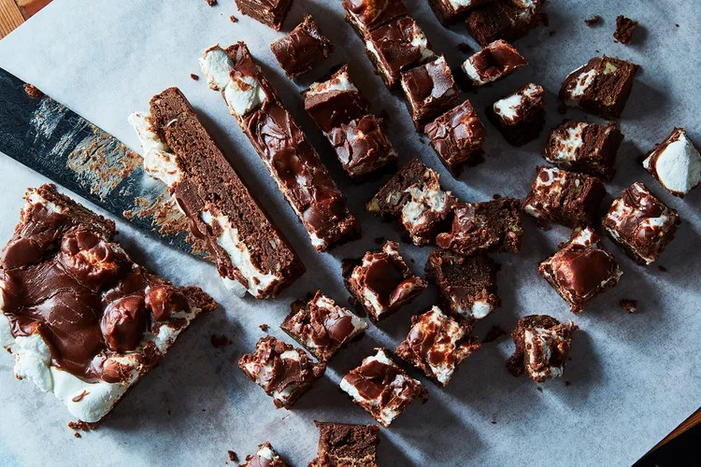
* **1 teaspoon**vanilla extract
* **1 cup**sifted flour
* **1 cup**chopped walnuts or pecans (optional)
* Marshmallows (enough to cover the pan)
* *For the frosting:*
* **2**squares (2 ounces) unsweetened baking chocolate
* **1**stick salted butter
* **3 cups**confectioners' sugar
* **1/4 cup**milk
* **12**marshmallows

*In This Recipe*

##### **Directions**

1. Grease a 9- by 13-inch baking pan and heat the oven to 350° F.
2. In the top of a double boiler, melt the chocolate and the butter together. Let cool.
3. Beat the eggs and the sugar well, then beat in the chocolate mixture and the vanilla extract. Add the sifted flour and nuts, if using, and stir until just combined. Pour into prepared pan and bake for 25 to 30 minutes (grandma says, "or more").
4. Meanwhile, quarter enough marshmallows to cover the top of the pan.
5. When the brownies are almost finished, make the frosting: Melt chocolate, marshmallows, and butter in the top of a double boiler. Add sugar and milk and beat until smooth (grandma says, "Beat until ready").
6. Remove baked brownies from the oven and immediately cover with the quartered marshmallows—no need to be dainty. Pour frosting over top and smooth with a nonstick spatula. Allow to cool completely before slicing into small pieces (I like to stick them in the freezer for an hour or so, and I then store them there, in a plastic container, too.)

# **Jacques Torres' Chocolate Chip Cookies**

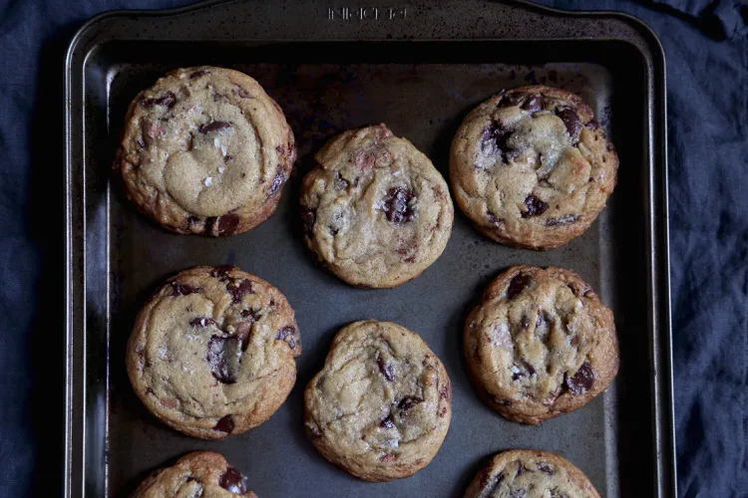

* PREP TIME24 hours
* COOK TIME15 minutes
* MAKES2 1/2 dozen large cookies

##### **Ingredientssend grocery list**

* **2 cups**minus 2 tablespoons cake flour
* **1 2/3 cups**bread flour
* **1 1/2 teaspoons**baking powder
* **1 1/4 teaspoons**baking soda
* **1 1/2 teaspoons**coarse salt
* **1 1/4 cups**(2 1/2 sticks) butter, at room temperature
* **1 1/4 cups**packed brown sugar
* **1 cup**plus 2 tablespoons granulated sugar
* **2**large eggs
* **2 teaspoons**vanilla extract
* **1 1/3 pounds**bittersweet chocolate discs
* flaky sea salt, for sprinkling

##### **Directions**

1. In a large bowl, whisk together the cake flour, bread flour, baking powder, baking soda, and coarse salt. Set aside.
2. In a large bowl or stand mixer, cream the butter and sugars until light and fluffy.
3. Add the eggs, one at a time, to the butter/sugar mixture and beat well. Add the vanilla and mix thoroughly, scraping down the sides of the bowl as you go.
4. Add the flour mixture gradually, beating until just combined, 5 to 10 seconds.
5. Fold in the chocolate using a spatula.
6. Press a piece of plastic wrap against the surface of the dough and refrigerate for at least 24 hours, or up to 72 hours.
7. When you're ready to bake, preheat the oven to 350° F.
8. Scoop large spoonfuls of dough onto a parchment-lined baking sheet (I did about 1/4-cup spoonfuls). Sprinkle with the flaky sea salt and bake for 13 to 15 minutes, or until the edges are just beginning to brown and the middle still looks soft.
9. Remove from the oven and let cool for a few minutes before transferring to a wire rack to finish cooling.

Drinks

# **Spring Sangria with Strawberries and Mint**



* SERVES6

##### **Ingredientssend grocery list**

* **12 ounces**light and dry white wine (we like Vinho Verde)
* **7.5 ounces**berry-flavored vodka
* **3 ounces**fresh lemon juice
* **1.5 ounces**simple syrup
* **2 cups**sliced strawberries
* Mint sprigs, for garnish

##### **Directions**

1. Combine all liquid ingredients in a large container and stir well to combine; then add strawberries. Cover and let rest in fridge overnight. To serve, ladle into ice-filled cups or wine glasses, and garnish each with a large mint sprig.

# **Papelón con Limón-Menta**



* MAKES4 to 5 cups

##### **Ingredientssend grocery list**

* *Miel de Papelon (Papelon Syrup)*
* **1 cup**cold water
* **1**8 oz. piece of panela (you can get this at Latin grocery stores)
* *Papelón con Limón-Menta*
* **3 cups**cold water
* **1/2 cup**miel de papelon (panela syrup)
* **3/4 cup**lime juice (6 to 8 limes)
* **1/4 cup**minced mint

##### **Directions**

1. *Miel de Papelon (Papelon Syrup)*
2. Combine the panela with 1 cup of water in a medium pot.
3. Simmer over low heat, stirring occasionally, until the panela has dissolved. Then increase the heat to medium and bring a boil.
4. Boil over medium-low heat, stirring frequently until the syrup has reduced by about 1/3 and thick enough to a coat a spoon, about 10 to 15 minutes. (Keep an eye on it while it cooks; panela syrup is prone to spilling over very quickly.)
5. When it’s as thick as the consistency of warm maple syrup, remove from the heat and let it rest until it cools completely. Store in a glass jar.
6. *Papelón con Limón-Menta*
7. Cut limes in half and squeeze until you get approximately 3/4 cup of lime juice.
8. Pour the lime juice into the pitcher, add the water, miel de papelon and stir, add mint and stir.
9. Let stand for a while, I recommend 1 hour, to absorb the flavor of the mint, before serving. You can strain the mint out if you dislike the texture or, alternately, can also blend into the drink.
10. Pour into a glass over ice and enjoy.

# **Passion Fruit & Mango-Mint Lassi**

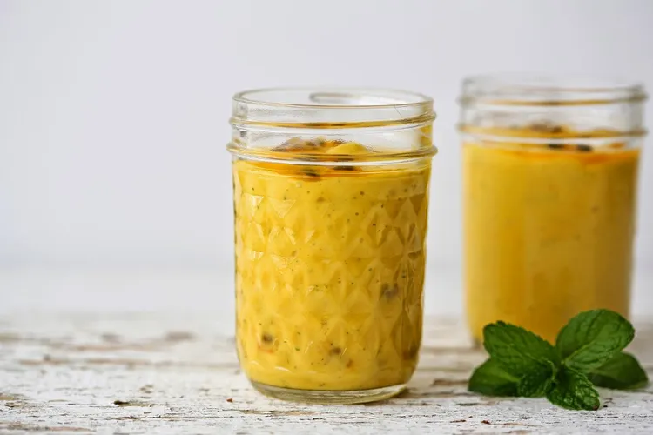

* 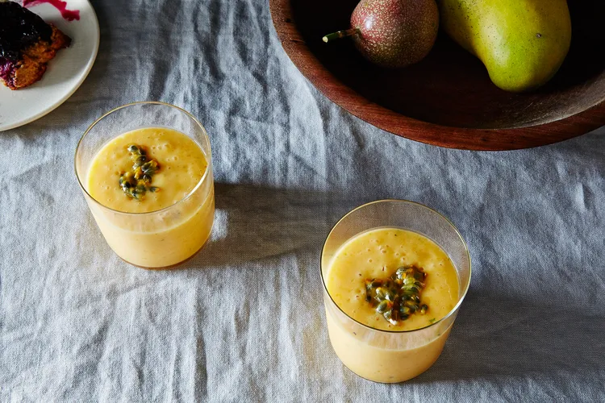PREP TIME10 minutes
* MAKES2 drinks

##### **Ingredientssend grocery list**

* **2 cups**flesh of champagne mangos
* **3**passion fruits, flesh only (reserve seeds for serving)
* **1/4 cup**yogurt
* **1/4 cup**coconut milk
* **6**mint leaves
* **1 handful**ice cubes
* **1 tablespoon**honey (optional)

##### **Directions**

1. With the exception of the honey and passion fruit seeds, place all of the ingredients in a blender and blend until smooth.
2. Taste for sweetness and add honey if needed. Divide between two glasses. Add the passion fruit seeds on top and serve immediately.

MEALS

# **Potato Gateau**

* PREP TIME10 minutes
* COOK TIME1 hour
* SERVES4 to 6

##### **Ingredientssend grocery list**

* **2 1/2 pounds**(1.2 kilograms) potatoes
* **4 tablespoons**grated Pecorino Romano
* **7 tablespoons**(100 grams) butter, cut into pieces
* **2**eggs
* **1/2 teaspoon**salt
* **1/2 teaspoon**grated nutmeg
* **1 dash**freshly ground black pepper, to taste
* **10 1/2 ounces**(300 grams) fresh mozzarella
* **3 1/2 ounces**(100 grams) gorgonzola or blue cheese
* **1 cup**(150 grams) prosciutto cotto, thinly sliced
* **3 tablespoons**bread crumbs
* **1 tablespoon**extra virgin olive oil

##### **Directions**

1. Peel the potatoes and cut them into 1/2-inch-thick slices. Steam the sliced potatoes in a pressure cooker for about 6 to 7 minutes. Alternatively, you can also boil the potatoes; in this case leave them whole, so they will absorb less water.
2. Preheat the oven to 350° F.
3. Mash the steamed potatoes in a bowl with a potato ricer. Mix the potatoes while they are still hot with the butter, eggs, grated Pecorino, salt, pepper, and nutmeg. Use a fork to make a creamy, smooth texture.
4. Grease an 9 x 9-inch baking dish or oven-safe pot and sprinkle with half of the bread crumbs. Spoon half of the mashed potatoes on the bottom and flatten the surface with a spatula.
5. Cover the potatoes with the prosciutto cotto and scatter the surface with pieces of mozzarella and gorgonzola. Top with the rest of the mashed potatoes, then flatten the surface with a spatula. Dust the surface with breadcrumbs, then drizzle with extra virgin olive oil.
6. 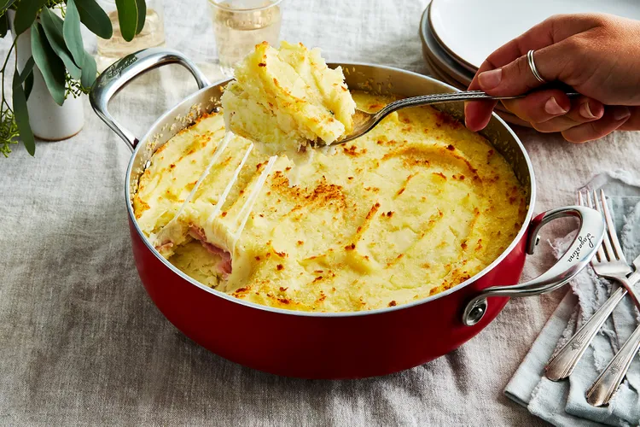Bake until golden and crisp, about 45 to 50 minutes, and serve warm.

# **Sweet & Savory Burger With Fig Jam, Goat Cheese & Arugula**

PREP TIME10 min

* COOK TIME15 minutes
* MAKES2 burgers

##### **Ingredientssend grocery list**

* **2**burger buns
* **1/2 pound**ground beef
* **1/2 to 1 teaspoons**crushed red pepper flakes
* **1/4 teaspoon**onion powder
* **1/4 teaspoon**garlic powder
* Salt and freshly ground black pepper
* **2 to 3 tablespoons**fig jam (I like Trader Joe's)
* **2 ounces**goat cheese
* **1 handful**arugula
* **1 teaspoon**olive oil

##### **Directions**

1. Preheat oven to 350° F. Place buns on a baking sheet, and toast in oven for about 10 minutes.
2. In a small bowl, drizzle olive oil over arugula, and season with salt and pepper. Give it a toss.
3. In a mixing bowl, combine ground beef with salt, pepper, crushed red pepper, onion powder, and garlic powder. Mix with your hands. (NOTE: Any time you handle raw meat, wash your hands thoroughly with soap and water before touching anything else.) Form beef into two patties.
4. Heat your cast iron skillet over medium heat. Melt butter or oil in skillet, and carefully place patties in pan. Always lay meat away from you to avoid splattering hot oil on yourself. Let patties cook for about 2 to 3 minutes before flipping (cooking time will depend on how thick your patties are). Once flipped, place goat cheese on each patty to warm and soften cheese. Cook second side for 2 to 3 minutes.
5. Assemble! Spread fig jam on the bottom bun. Place patty on top of fig jam. Top patty with arugula. Top arugula with top bun.

# **Red Roasted Asian Beef Stew**

* SERVES6

##### **Ingredientssend grocery list**

* **4 pounds**beef chuck cut into 2 inch cubes
* **1**English short rib (1/2-1 lb) (optional)
* salt and pepper
* **1-2 tablespoons**vegetable oil
* **1 cup**sweet rice wine, sake, or sherry
* **1/3 cup**soy sauce
* **1 teaspoon**rice wine vinegar
* **2 cups**chicken stock
* **1-2 tablespoons**brown sugar or an equivalent amount of rock sugar (adjust seasoning to taste)
* **2**star anise
* **1**slice ginger root
* **6**garlic cloves
* **3-4**red chili peppers, fresh or dried (again, suit to taste)
* **3**whole dried shiitake mushrooms or fresh ones cut into quarters
* **1**lime, zested
* **3-4**large carrots, peeled and cut into 1 inch pieces
* **1**large daikon, peeled and cut into 1 inch pieces

##### **Directions**

1. Heat oven to 325 degrees. Season meat with salt and pepper. Heat oil in a large ovenproof pot with a tight-fitting lid. Working in batches brown beef all over, removing each piece when done. Add oil as needed.
2. Add all meat back to pot. Add wine and vinegar and bring to a boil, scraping up browned bits. Add soy sauce and sugar then the stock. Add star anise, ginger, garlic, chili peppers, and mushrooms and bring to a boil. Return beef to pot and add lime zest. Add water to cover meat. Cover, transfer to oven.
3. Check pot after 1 hour. Turn over pieces of short rib and stir meat. Cover again and cook 1 hour more, or until meat is tender.
4. Move pot to stove top. Simmer on medium heat with lid off to reduce liquid. Cook for 30 minutes.
5. To eliminate fat: Depending on your cut of meat, the stew can be very greasy. You can spoon off the fat or poor cooled sauce into a fat separator to remove fat. Alternatively, place pot in refrigerator overnight. Scrape off fat the next day.
6. Before serving, reheat the stew and cook without the cover to reduce the sauce a little. At the same time, boil vegetables in a large pot of water for 20 minutes. The vegetables are boiled separately to make sure they do not overcook and retain their color. In addition, raw daikon tends to have a very strong flavor that I don’t like in the stew. The boiled daikon is mild.
7. Add boiled vegetables to stew. Serve with fresh hot rice or noodles. Also try it with a sprinkling of chopped green onion and a squeeze of lime.
8. Leftovers make a delicious noodle soup. Bring a pot of water to a boil. Add noodles. When the noodles are almost done, throw in a large handful of fresh spinach. Cooked until wilted, then drain noodles and spinach. Toss with enough sesame oil to coat noodles (1/4-1/2 tsp). Add meat and meat sauce. Pour hot water or chicken stock to cover the noodles and stir. Add soy sauce, meat sauce, chopped green onion, and/or lime to taste. This noodle soup is awesome with a big helping of chili sauce.
9. Slurp.

